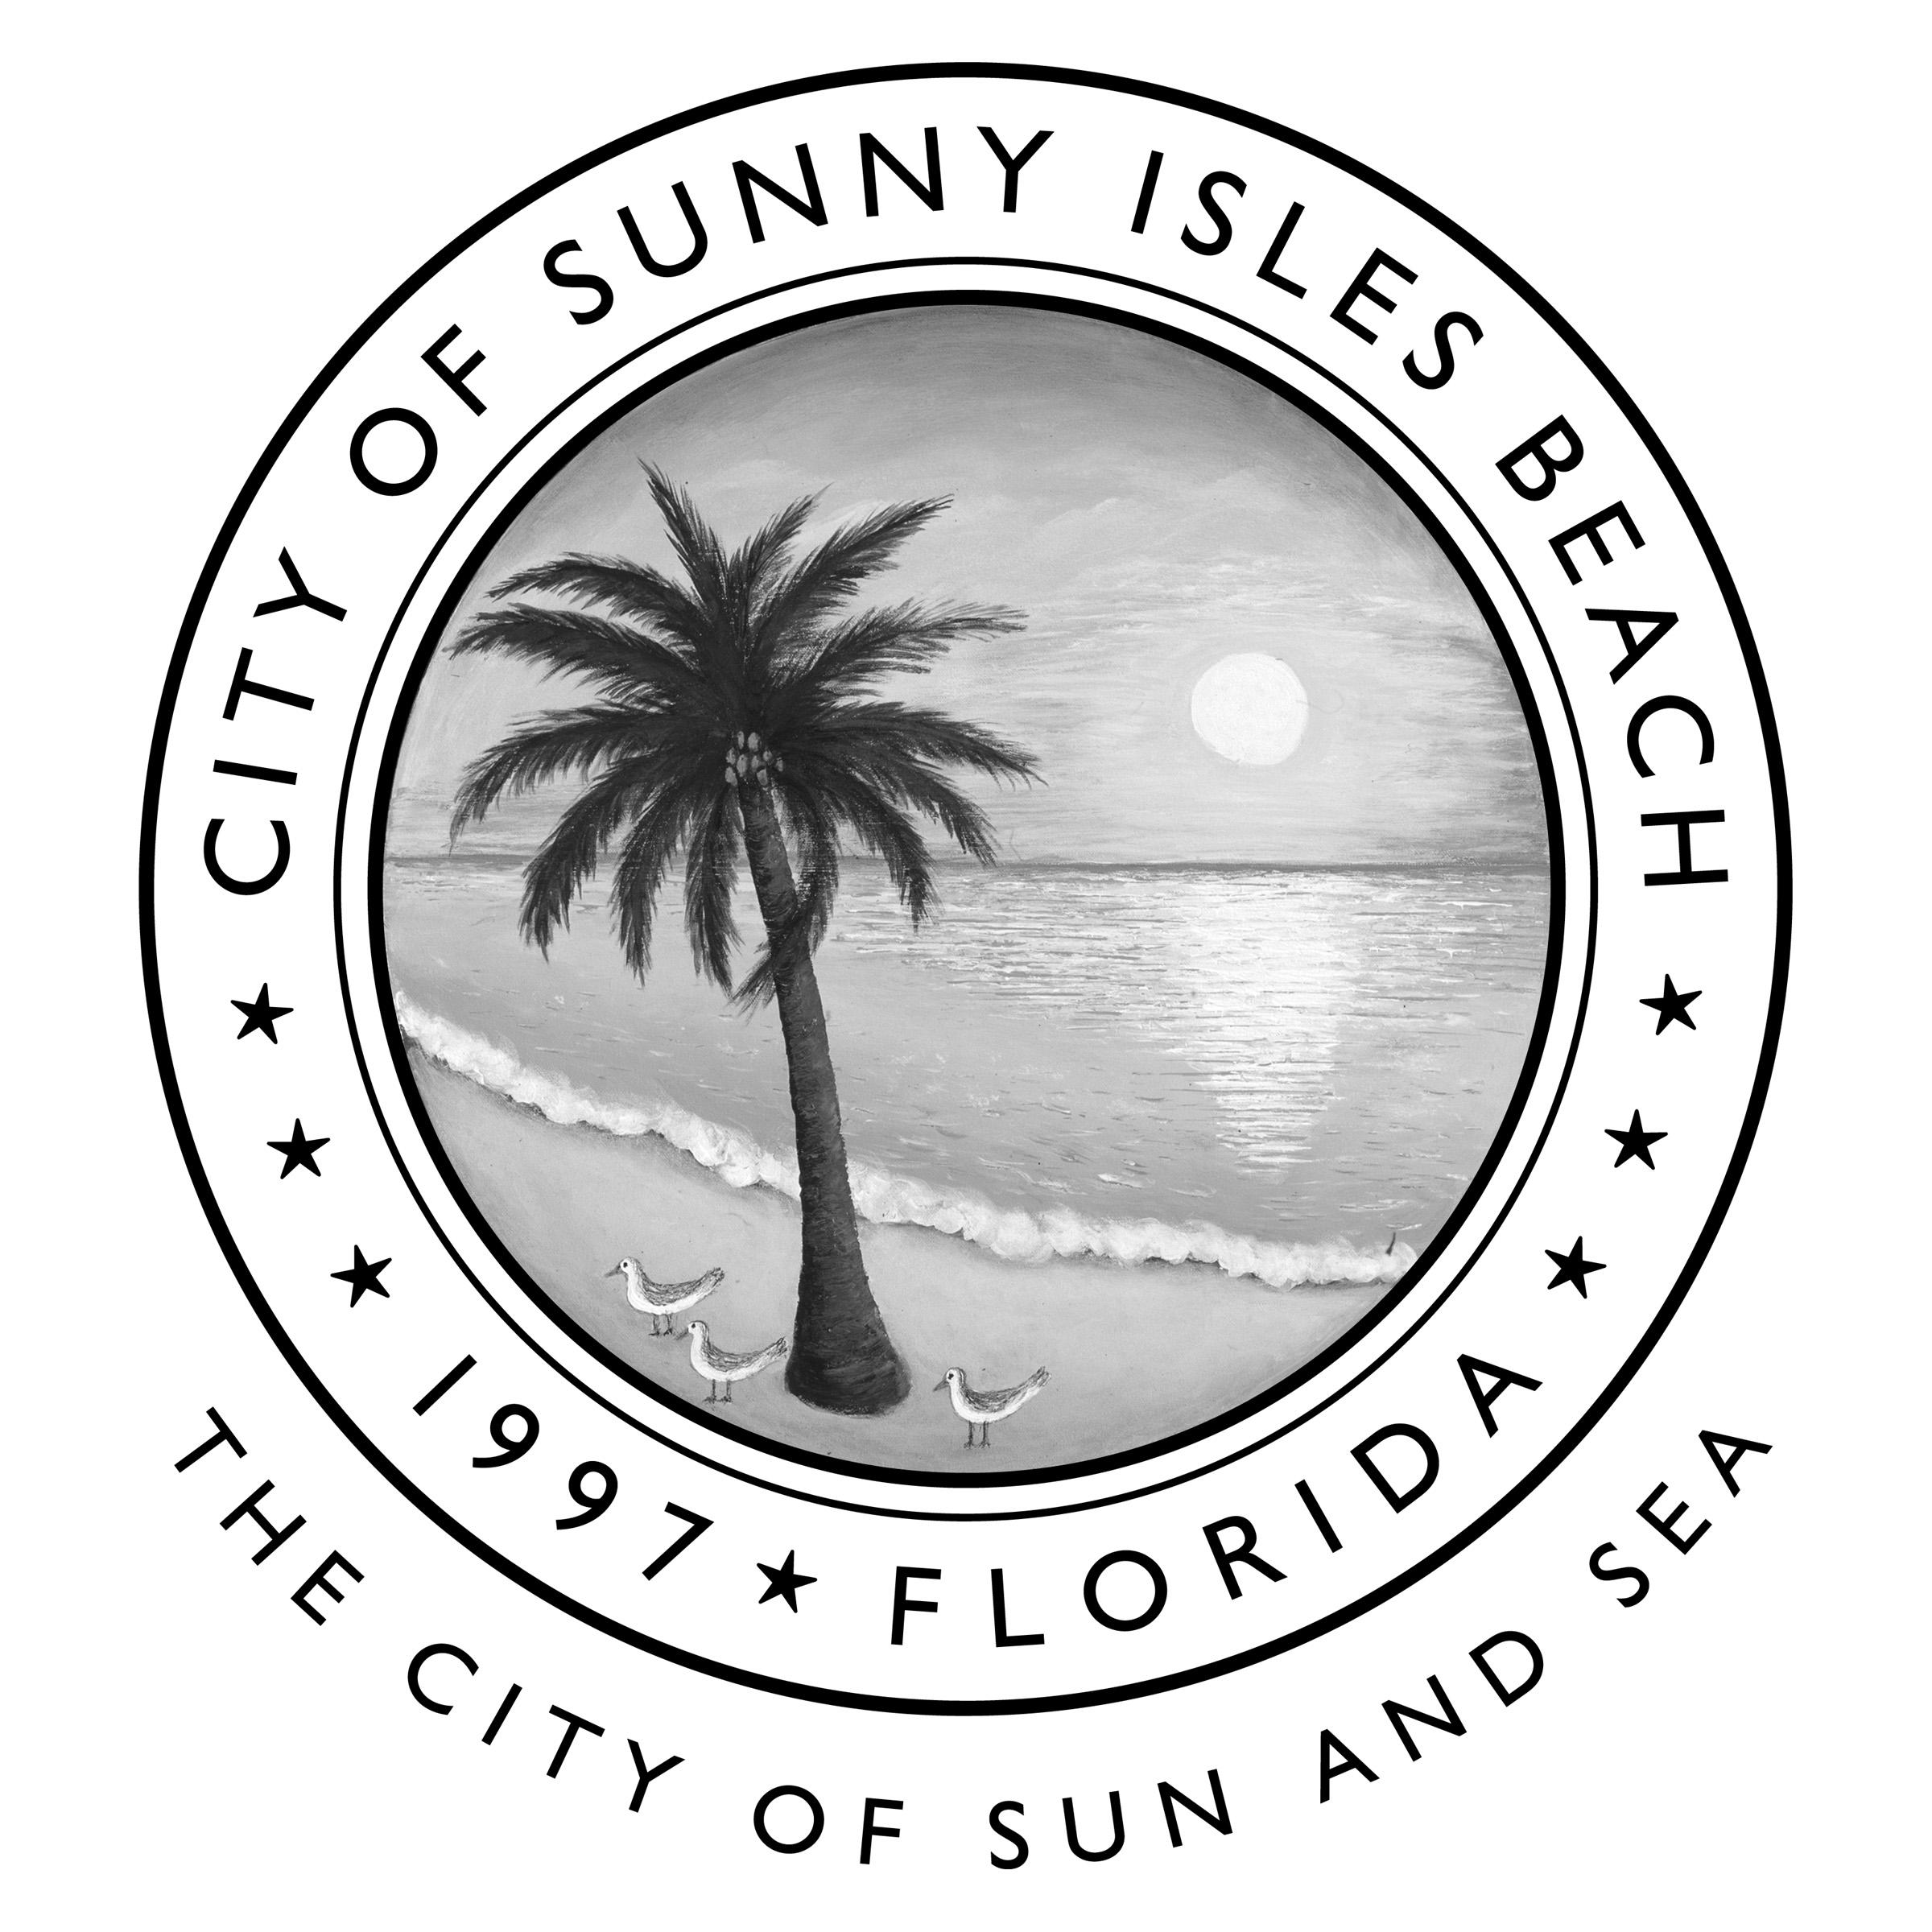

Request for Clarification No. 1

CITY OF SUNNY ISLES BEACH
Project Name
CITY RFQ NO.

To All Bidders:

Bidders for the above-referenced project shall take note of the following changes, additions, deletions, clarifications, etc. to the Plans and Specifications, which in accordance with the Contract Documents shall become a part of and have precedence over anything shown or described otherwise.

- Request for Clarification:

- Does the City operate their own fleet maintenance facility?

The City does not have a fleet maintenance facility

- Is this bid for overflow work that the city’s fleet maintenance department chooses not to perform themselves?

City does not maintain their vehicles in house.

END OF SECTION

